

PRODUCT SPECIFICATION SHEET

INTEGRA ELLIPSE CABINET

KHP PART No. CAB ITG ELP

DESCRIPTION

- Strong transparent ABS towel bin.
- Designed to be used with 40M long standard towel, up to a max width of 270mm
- Replaceable front insert
- Tough, long lasting mechanism with steel gears.
- Self-supporting lid with tamper proof snap lock.
- Minimum maintenance required, with easy availability of spare parts.
- Left/Right hand lock. Locks uses key common with other products in the range

DIMENSIONS

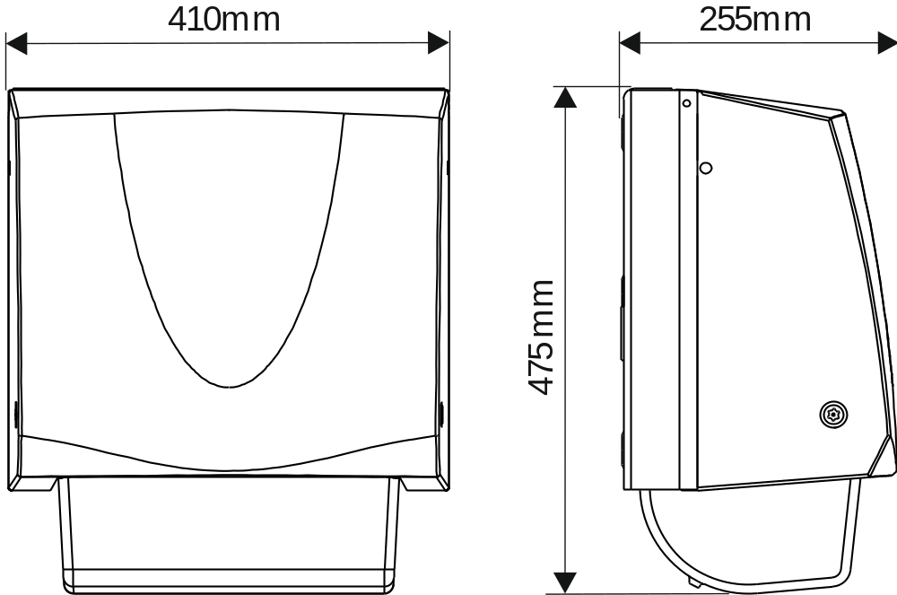

MATERIALS

Backplate made from steel and painted black. Front cover and various internal parts made from ABS and other engineering thermoplastics.

PACKAGING

2 Cabinets are packed into a double wall box with key and instruction sheet.
Box dimensions: 52cm x 41cm x 39cm
Individual Weight: 6.5Kg
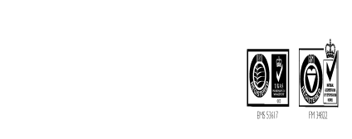Total weight: 15kg

