

# PRODUCT SPECIFICATION SHEET

# EASYROLL

##### KHP PART No: TSD EZY ELP

## DESCRIPTION

* Paper towel dispenser for washroom, kitchen and hospitality environments.
* Fixes to wall using screws.
* Patented adjustable tension ring to provide controlled paper feeding for both perforated and continuous paper.
* The unit can be secured with the standard Kennedy key or can easily be converted for keyless opening using an opening knob included with product.

**DIMENSIONS**

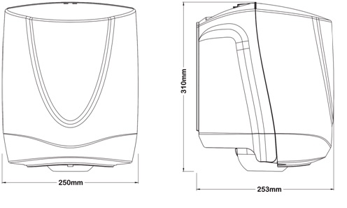

#### MATERIALS

Backplate and Cover moulded in low warpage Polypropylene. Rest of the parts in Acetal.

Individual Total weight : 911 grams

**PACKAGING**

Two units per box separated with a cardboard divider. Opening knob stuck to Back Plate inside the unit. Every unit is packed in a polyethylene bag.

Carton dimensions (LWH) : 51.5cm x 27cm x 33cm

Total weight of carton : 2.3kg

