

PRODUCT SPECIFICATION SHEET

SAVONA FOAM SOAP DISPENSER

KHP Part No: SPD SAV FOA UNP (& VARIANTS)

DESCRIPTION

• A soap dispenser delivering foam soap.
• Consumable/bottle contains 800ml of foam soap.
• It is advised that units are screwed to the wall using the 3 screws provided in the fixing pack.
• Adhesive pad kits are available, in a standard form or a special cold application version.
• Cover opens at the top using the key provided.
• Window allows verification of remaining contents.
• Nominal 0.4 ml dose.

DIMENSIONS

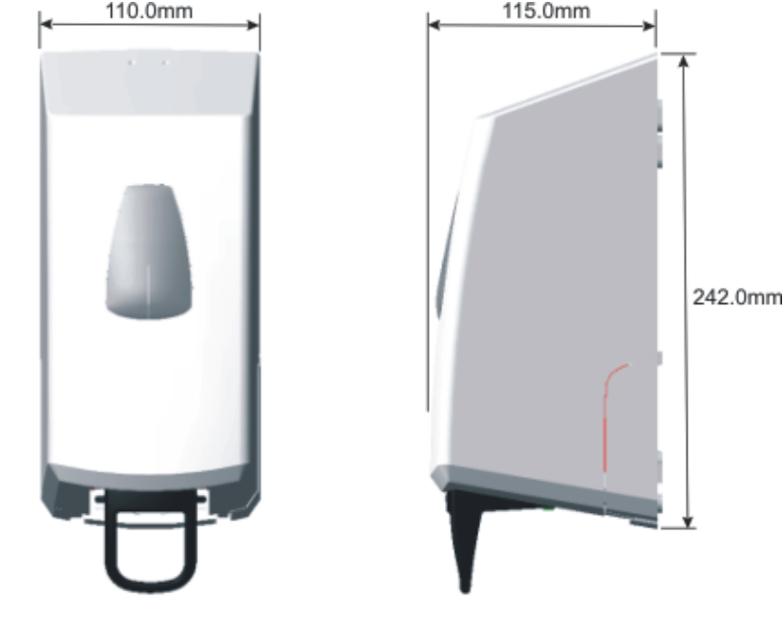

MATERIALS

Constructed fully from recyclable thermoplastics.

PACKAGING

Individual units are packed in a polythene bag with a fixing pack. 12 units and one installation/operating instruction sheet

Individual weight of unit: 470grams
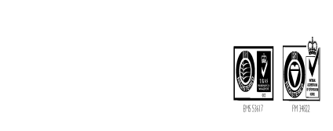Box size: 496mm x 336mm x 241mm
Total weight: 6.36Kg

